Contents

1. Intersection Level of Traffic Stress (LTS) criteria 3

1.1. Introduction 3

1.2. Criteria Table A: Stand-alone path crosses a 2-lane road 3

1.3. Criteria able B: Other unsignalized crossings where bikes are expected to stop or yield 4

1.4. Criteria table C: Signalized crossings 5

2. Data sources 7

2.1. Introduction 7

2.2. Street network layer 7

2.3. Traffic signals layer 9

2.4. Stop signs layer 9

2.5. RRFB and crossing islands (interventions) layer 10

3. Spatial data structure for intersection and modeling of the crossing movements 11

3.1. Introduction 11

3.2. Data import process 12

3.3. Data import order 12

3.4. Intersection’s data and crossing movement models 13

3.5. Crossing movements model and its attributes 19

3.6. Attributes of a simple crossing (crossing one segment) 20

4. Visualizing the crossing barriers across the street network 22

4.1. Introduction 22

4.2. A geometry for the crossing relations 22

5. Cases from Delaware 23

5.1. Standalone trails and side paths crossings 23

5.2. Unsignalized crossings crossed traffic speed of less than 35 mph 25

5.3. Unsignalized crossings crossed traffic speed of more than 35 mph 26

5.4. Signalized crossings Crossing distance more that 100 ft 27

6. Current issues and future works 30

6.1. Unsignalized crossing of dual-carriageways as two-stage crossing movement 30

6.1. Unsignalized crossing of dual-carriageways as one-stage crossing movement 30

7. Pseudocode for the procedure 32

## Intersection Level of Traffic Stress (LTS) criteria

### 1.1. Introduction

This chapter is to provide an overview of the criteria used for assigning a Level of Traffic Stress (LTS) to intersections *crossing* with the emphasis on the data requirements, and algorithm implementation. The cycling Level of Traffic Stress (LTS) for intersections crossings is developed by Furth and X (202X) for the Delaware Department of Transportation (DelDOT) as part of a research on methods for prioritizing cycling investment and improvement projects across the state.

Cycling intersection crossing Level of Traffic Stress (LTS) is defined using a set of criteria tables, each associated with a crossing situation, or type, which are grouped based on characteristics of the intersection and the path on which the cyclist is traveling from. Within each table, the Level of Traffic Stress is assigned based on the characteristics of the crossed over traffic, i.e., volume and speed.

The three criteria tables presented here include those for which appropriate data was available and was provided by Delaware Department of Transportation (DelDOT). The first criteria table is organized based on the road the cyclist is traveling on, i.e., traveling on a stand-alone path crossing over two lanes of traffic that has RRFB, or a crossing island, and the other two tables are organized based on the characteristics of the intersection i.e., if it’s signalized, or not signalized.

### 1.2. Criteria Table A: Stand-alone path crosses a 2-lane road

The first criteria table applies to stand-alone trails crossing two lanes traffic, where the traffic is expected to yield to cyclists. The logic behind this criteria table is that if the cyclist has sufficient opportunities to cross, which is measured in terms of average delay, and with more gaps between the traffic meaning more crossing opportunities, and thus lower LTS.

This table accounts for the common intersection treatments, including Rectangular Rapid Flashing Beacon (RRFB)s, and crossing islands. The street network layer attribute, i.e., functional classification property is used to find if the crossing is from and to a stand-alone trail. Locations of RRFBs and crossing islands from the intersection treatments layer are used to determine if the crossing has RRFB and/or a crossing island. Street network layer also provides information on speeds, and the traffic volume used in this table.

Due to the unreliability of the median width data of the divided highways (explained further in details in the data layers section), crossing divided highways are considered as one crossing with the median considered as a crossing island. Future research, with more accurate median width data, could use a median width value (e.g., 20 ft) as a minimum threshold of the length of a median for considering a divided highway to be counted as a crossing island or not.

|  |  |  |  |  |  |  |
| --- | --- | --- | --- | --- | --- | --- |
| RRFB? | ADT | SPD ≤ 25 mph | | SPD = 30-35 mph | | SPD > 40 mph |
| With Xing Island | No Xing Island | With Xing Island | No Xing Island |
| With RRFB | Any | LTS 1 | LTS 1 | LTS 1 | LTS 1 | * |
| No RRFB | ≤ 8000 | LTS 1 | LTS 1 | LTS 1 | LTS 1 | * |
| > 8000 | LTS 1 | * | * | * | * |

* LTS is either 2 or 3; use Table B

Note: shaded cells are those for which motorists are expected to stop to let cyclists cross.

Note: for trail crossings of multilane roads, use Table B.

##### Table A: Where a stand-alone path crosses a 2-lane road and bikes are expected to stop

### 1.3. Criteria able B: Other unsignalized crossings where bikes are expected to stop or yield

For bikes riding along a road and crossing a road, and for bikes riding on a stand-alone path and crossing a multilane road on an unsignalized intersection, if bikes are expected to stop or yield, table B is applied. To determine if the bike is expected to stop or yield, a priority level is assigned when crossing over a segment, by asserting the presence of ‘stop signs’ on those segments at the crossing location. If there are no stop signs, the functional classification of the segments being crossed over are used, in relation with the segment the travel is coming ‘from’, for example, the priority of crossing of the ‘from’ segment over the ‘-crossed-over’ segment is categorized as a ‘local-crossing-local’ if the ‘from’ Segment and the segment being crossed over are both ‘local’ streets. If the segment being crossed over and the ‘from’ segment both have ‘stop’ sign at the crossing location, or the segment being crossed is a ‘local’ street, and the ‘from’ segment is either an arterial, collector, or trunk street and has a ‘stop’ sign at the crossing location, we categorize the crossing as a ‘4-way stop’.

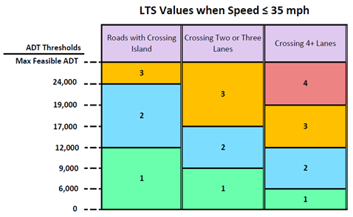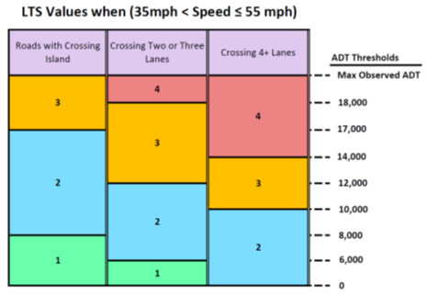

##### Table B: Unsignalized crossings where bikes are expected to stop, for bikes riding along a road and crossing a road, and for bikes riding on a stand-along path and crossing a multilane road

### 1.4. Criteria table C: Signalized crossings

The third table is applied to all signalized crossings. Traffic signals point layer data is used to determine the existence of traffic signals in proximity of the intersection, however, only two criteria for signalized crossings (highlighted in the table below) could be implemented due to data unavailability. The logic for applying the triggers in the table are as follows: LTS level is 3 if any LTS 3 trigger applies. Otherwise, LTS is 2 if any LTS 2 trigger applies. Otherwise, LTS is 1.

|  |  |  |
| --- | --- | --- |
| Factor | LTS 3 Trigger | LTS 2 Trigger |
| Permitted left turn volume | Permitted left turn crosses 2 or more through lanes, any volume | Permitted left turn crosses 1 through lane and left turn volume > 75/h in peak hour |
| Permitted right turn volume |  | > 75/h in the peak hour.  > 150/h if there is a leading bike interval |
| High speed permitted left turn | Left turning vehicle path radius > 120 ft and speed limit > 30 mph | Left turning vehicle path radius > 60 ft |
| High speed permitted right turn | Right turning vehicle path radius > 100 ft and speed limit > 30 mph | Right turning vehicle path radius > 50 ft |
| Crossing island size  For islands in which bikes are expected to wait | Island length, measured along bike path, < 8 ft | Island length, measured along bike path, < 30 ft |
| Channelized right turn on departure side  with bike lane to the left of the delta island | At the end of a crossing, bikes are between a travel lane on their left and an added lane on their right, such as an acceleration lane continuing from a channelized right turn lane. |  |
| Crossing length  Does not apply if bike phase has a countdown timer in every cycle in which bikes cross. |  | Crossing distance > 100 ft. |
| Minimum green  Is resulting minimum phase length long enough for a bike to cross from a standing start? | Minimum green is more than 2 s shorter than recommended    needs recommended minimum green times | Minimum green is between 0.1 and 2 s shorter than recommended. |
| Clearance time  Long enough for a bike to cross from a rolling start?  Does not apply if bike phase has a countdown timer in every cycle in which bikes cross. | Clearance time is more than 2 s shorter than recommended    needs recommended clearance times | Clearance time is between 0.1 and 2 s shorter than recommended. |
| Pushbutton setback  .(applies where bikes have to push a button for service) |  | Pushbutton is set back less than 3 ft from the curb |
| Pushbutton offset  (applies where bikes have to push a button for service) |  | Pushbutton offset more than 2 ft from the curb ramp or (where there is no ramp) path |
| Mixing zone / through bikes using a right turn lane |  | Right turn volume < 50 veh/h in peak hour |
| Pocket bike lane  (bikes between a right turn lane and through lane) | [If pocket lane doesn’t conform to LTS 2 criteria, use segment LTS for bikes in mixed traffic. Could be LTS 3 or 4] | LTS for a conforming pocket bike lane is 2 |

* not applied to Delaware due to data unavailability.

##### Table C: signalized crossings

## 

## Data sources

### 2.1. Introduction

A set of geospatial data layers representing the road network and transportation infrastructure of the state of Delaware is used for implementing the logic for assigning the crossing LTS to intersection crossings. These include the street network layer representing the road network, various point layers representing the location of the traffic signals, stop signs, and a layer representing the location of all intersection treatments such as RRFBs and crossing islands. Each is described in more detail in the following section.

### 2.2. Street network layer

DelDOT provided the street network data as a line feature class in an ESRI Geodatabase format, which contained the common street network GIS properties, that is its physical and topological properties i.e., the geometry of the street centerline, and a set of descriptive attributes. Each feature in the feature class is a street segment, represented by the street centerline geometry, and is stored as a linestring along with a set of properties in its attribute table. Linestring is a data structure for storing line geometries and is spatially made up of a set of point locations.

The provided street data is a ‘network workable’ layer, meaning if two streets have an intersection in the real world then the two line segments representing them would also intersect (Karduni et al., 2016), that is, the start/end points of the two linestrings are co-located. This is important since it’s the basic criteria for finding intersections.

The DelDOT street layer’s attribute table provided the following fields for each line feature representing a street segment centerline: ‘number of lanes, lane type, lane width, shoulder width, bike lane width, traffic volume, traffic speed, functional classification, street name, and the road ID.

#### 2.2.1. Forward/backward line attributes for two-way streets represented by a centerline

Each linestring has an inherent directionality based on the order of which the vertices are drawn. For a two-way street that is represented with only one centerline, each street side is identified according to the drawn directionality and the properties are stored separately for each side. For example, for storing the information for the ‘number of lanes’ for both sides, two columns of ‘number of lanes forward (right)’ and ‘number of lanes backward (left)’ exist in the attribute table, where the forward refers to the side of the street that matches the direction in which the line is drawn. In the Delaware street network data, the indication is done by adding a prefix ‘L_’ and ‘R_’ to the field names. For example, the field ‘R_LANE_N’ and ‘L_LANE_N’ for indicating right and left *(forward and backward) respectively

#### 2.2.2. One-way streets represented by a geometric centerline

Each line segment has a ‘one-way’ field indicating if the segment is part of a one-way street. In Delaware’s street network layer, this field has two other possible values of ‘two-way’ for if a line segment represents a two-way street segment, and ‘divided highway’ for if the line segment is part of dual carriageway.

#### 2.2.3. Divided highway/Dual carriageways

A common practice in street network data storage is to represent dual carriageways (or divided highways) with two parallel centerlines. Dual carriageways, or divided highways are physically divided by a barrier, or separated by a median. In Delaware, this information is expressed as a value in the field ‘one-way’ of the street network layer as an attribute for each street segment. There are three possible values: one-way street, two-way street, or a one-way street as part of a dual carriageway.

#### 2.2.4. Number of lanes, lane widths, and bike lanes

The Delaware street network dataset has multiple fields for storing the information regarding the number and configuration of lanes on the road surface for each road segment. This includes fields for ‘number of through lanes’, ‘number of lanes’, ‘lane width’, ‘left turn lane width (if any)’, ‘shoulder lane width (if any)’, ‘bike lane type (if any)’, and ‘bike lane width (if any)’. For streets indicated as bidirectional, the number of through lanes provided reflects the sum of the two directions. For one-way streets, as well as dual carriageways, the number of through lanes provided is for one direction only.

#### 2.2.5. Width of the median divider

Width of the median for streets with a physical divider between two directions is provided by the DelDOT.

#### 2.2.6. Traffic volume and speed

The Delaware street network data set has fields for Average Daily Traffic (ADT) from the state’s traffic counts data, and traffic speed collected by the state from connected vehicles (using GPS tracks) in the format of mph. The ADT and speed values for most of the street infrastructure available (**). For dual carriageways, the same ADT value is stored to both features representing the two directions of a divided street segment, thus ‘effective’ ADT on two directions becomes half of the stored ADT. Delaware stores the 85th percentile for the speed value for each street segment.

### 2.3. Traffic signals layer

A point layer representing location of traffic signals provided by DelDOT. The points’ locations are used to find and assign them to the intersection that’s in close proximity through the data import process.

### 2.4. Stop signs layer

A point layer representing the locations of all traffic signs are provided by DelDOT. Moreover, each point attribute includes the sign type, and the road_id of the street that the sign applies to. Through the data import process, the road_id is used, in combination with the type of ‘stop signs’, to find the street segments with the same road_id and their start/end point in close proximity to the sign’s location. The stop sign layer’s road_id attribute is crucial to the efficiency of the work, since using only spatial proximity assigns the stop sign to all incident segments of a given intersection node even if the sign only faces some of the segments. (....)

### 2.5. RRFB and crossing islands (interventions) layer

A point layer representing the location of RRFB and crossing islands is provided by DelDOT. The points are used to find the intersection in a proximity through the data import process. The features in this layer, however, aren’t identified with a street using IDs (unlike the stop signs layer). Using the RRFB and crossing island’s locations only for assigning them to intersections nodes has the caveat that they could be incorrectly applied to the crossing movements from and two the streets they are in fact help to cross over. However, this wouldn’t have an impact on the analysis due to the following assumption. The RRFB, and crossing islands are arguably created for calming a high volume and faster traffic of vehicles where there is a conflicting cyclist or pedestrian trying to cross the vehicle traffic. The reverse of this, meaning the high-volume traffic crossing over the cyclist, or pedestrian paths could be assumed to be a low stress crossing. Therefore, applying a RRFB or a crossing island wouldn’t have any impact since the crossing LTS on the wrong movement is already low.

## 

## Spatial data structure for intersection and modeling of the crossing movements

### 3.1. Introduction

The Delaware street network layer is in the form of linear features, or lines geometries stored as ESRI feature class within a Geodatabase, and as the most common GIS formats, it doesn’t afford combining different geometry types within a single feature class. For analyzing crossing intersections, the point features, e.g., geometries of the traffic signal locations are needed to be represented for applying the LTS criteria for the crossing movement model. Furthermore, we need to be able to represent abstract concepts e.g., priority in crossing for analyzing a crossing movement of an intersection in a realistic way. To deal with these difficulties, we process each dataset into a unified data structure throughout an import process using the Python programming language. This data structure is defined following the ideas of a geo-atom (Goodchild et al., 2007) , and the OpenStreetMaps (OSM) data structures.

We define ‘nodes’ as the most primitive form of our data structure, and an association between a point location in space and a property. Nodes are point features with spatial attributes expressed as latitude and longitude values, and additional attribute properties associated with them e.g., a traffic sign is stored by referencing a node along with other properties such as the type of the sign etc... (Having the data structured in this format also enables us to use the OSM’s library of tools and softwares, and thus being able to visualize the data using OSM tools.)

Other geometry types are spatially located by referencing a list of nodes, representing vertices of their geometries, along with properties associated with each feature. For example, street centerlines with multiple line segments are stored with references to an ordered list of node IDs where each node represents a vertex, along with other properties including a segment ID, direction, etc.. Nodes stored as line vertices would also have a list of the incident line segments added to their properties. An incident segment of a node would have that node’s id referenced as one of its vertices.

### 3.2. Data import process

We process the transport network data into the node-atomic data structure and store it within a database schema like OpenStreetMap data model. We defined three primary object types: nodes, segments, and relations. A segment could be conceptualized as a sequence of nodes and a relation as a collection of nodes, segments, or both. We import the datasets by processing their features one-by-one, in a way that throughout the import process, a list of unique nodes would be populated and stored. We break down each imported feature’s geometry to its vertices. We use a function for generating nodes (node-generate-update function) that takes coordinate values (latitude and longitude pair) and returns a node ID. Internally the function checks for if a node already exists located at the provided coordinate and returns its ID, and if it doesn’t exist, it adds the node, assigning a new ID and returning the ID. We do this for all vertices of a feature and store the feature properties along with the list of node IDs referencing the vertices.

### 3.3. Data import order

Street network layer is the backbone of our data structure since we are interested in modeling crossing intersections, thus we start by importing street lines, one by one, passing each line's vertices through the node-generator-or-update function, and storing each as a segment. We recognize that point type layer data features only in relevance to a node imported via the street network, that is, instead of passing the points to the node-generate-update function, we restrict the function to only update an existing node by adding its attribute, and discard if no nodes are found with the given coordinate and a buffer to search around for existing nodes. For example, we import the points representing the location of intersection treatments, i.e., RRFB and crossing islands by first transforming them to a buffer geometry (with 0.0002 decimal degree buffer size) and performing a spatial inner join with the nodes in our data structure. This process would add the attribute of the RRFB layer, including if there is RRFB and crossing islands to the existing nodes within the 0.0002 decimal degrees linear distance.

We import all other layers in a cumulative manner, updating existing nodes with each layer’s attributes by doing the mentioned process. We will be able to determine if an intersection has a certain property, e.g., if it’s signalized, by assessing if the intersection’s node has an updated attribute value from an imported data feature, Conversely, the absence of the value, or a null value, would indicate that the attribute does not exist on the intersection, or for the mentioned example, would mean that the intersection is unsignalized.

### 3.4. Intersection’s data and crossing movement models

Two street lines have an intersection with each other if they share a vertex. Using the data schema defined before, an intersection could also be defined as nodes with more than two incident segments. However, this structure wouldn't suffice when divided highways intersect with other streets. Data for divided streets, or dual-carriageways, includes two centerlines, each per direction, stored as two separate features. Therefore, two data structures are defined for modeling intersections; First, single-node intersections are defined with a node with two or more incident segments and; second, the multi-node intersections, are defined where an incident segment is shared by two nodes that have each side of the same dual carriageway as their incident segment.

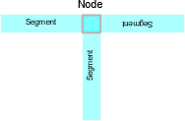 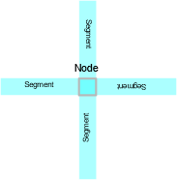

##### Figure 1: schematics for single-node intersections

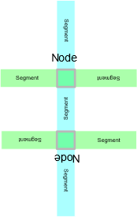 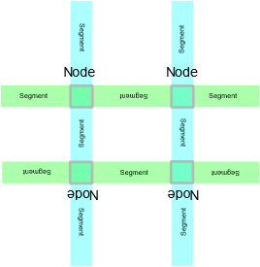

##### Figure 2: schematics for multi-node intersections for representing intersections of centerline and dual carriageway models of street representation.

#### 3.4.1. Single-node intersections data and crossing movement models

For single-node intersections, we order incident segments in descending order based on their bearing, which is the same as ordering them counter-clockwise starting from due north. We annotate the segments based on their index in the ordered list of incident segments.

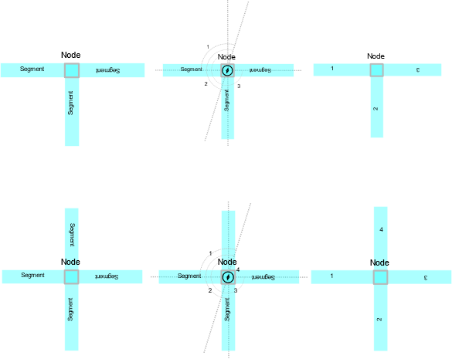 

##### Figure 3: schematics for single node intersection annotation based on the segments index in the ordered list of incident segments.

The crossing itself is stored as a ‘relation’ data type with references to a ‘from’ segment ID, a ‘to’ segment ID, and a ‘via’ node ID, basically in the same way a turn-restriction, e.g. a no-left-turn restriction in OSM. For single-node intersections, a crossing relation is categorized not based on the ‘from’ or the ‘to’ segments, but based on how many, speed and the traffic volume of the travelling lanes of the other incident segments of the via node in the intersection, and the priority the traffic travelling in the ‘from’ segment in relation to the segments being crossed.

We find the number of segments that are crossed in a crossing movement by calculating the difference of the index’s values of ‘from’ segment and ‘to’ segment in the ordered list of incident segments, modulo the number of incident segments the ‘via’ node has, minus 1. For example, going from segment 1 to segment 3 in a T intersection (figure 4.a) would include crossing 1 segment ( mod((3-1), 3) - 1 = mod((2), 3) - 1 = 2 - 1 = 1). In a 4-way intersection going from segment 4 to segment 3 (figure 5.c) would include crossing over two segments since mod((3-4),4)-1 = mod((-1),4)-1 = 3-1 = 2.

We find the segment(s) being crossed by their index value in the ordered list of incident segments. The crossed over segment’s index could be calculated as mod((i + n -1), N)+1, where i is the index of the from segment, n is an integer between 1 and number of segments being crossed over, and N is the total number of incident segments. For example, going from segment 3 to segment 2, and crossing over two segments, n takes on values of 1 and 2. For n=1, using mod((3 + n – 1),4) + 1 = mod(3,4) + 1 = 4, which is the index of the first crossed over segment; with n=2, mod((3 + n – 1),4) + 1 = mod(4,4) + 1 = 1, the second segment.

##### abcde f

##### 

##### Figure 4: single-node intersections’ one-stage crossing movement model

In this structure, a multi-stage crossing is modeled where there are more than one incident segment being crossed over when traveling from the ‘from’ segment to the ‘to’ segment. In a multi-stage crossing, when there are more than one critical crossed-over incident segments, the maximum LTS value for the crossing over those would be assigned to the compounded multi-stage crossing.

##### a b c d

##### 

##### Figure 5: single-node intersections’ two-stage crossing movement model

#### 3.4.2. Multi-node intersections data crossing movement models

In most common spatial datasets used in transportation analysis, a divided highway, or dual carriageway is represented by two sets of segments, each representing an imaginary centerline for each direction of traffic. For multi-node intersections, we find the midpoint of the nodes with the shared dual carriageway, then assign the nodes' incident segments to the midpoint locations. We then order the segment counterclockwise starting from due north and annotate them with their index in this ordered list. The crossing data model when crossing a dual carriageway is stored with references to ‘from’ segment ID, ‘to’ segment ID, and ‘via’ segment ID. The ‘via’ segment is defined as the segment constructed by references to the nodes at which each direction of a divided highway intersects with the ‘from’ and ‘to’ segments.

We identify multi-node intersections by the segment that connects the two nodes that result by intersecting two directions of a divided highway. These ‘median segments’ are found using two steps. First we find a node with an incident segment attributed as a ‘divided highway’ in its list of incident segments. This segment’s bearing is used for locating the dividing segment, since it would always be located on the left in respect to the direction of the divided highway. Then we iterate through the incident segments of the node until we find the incident segment, which has the second node, which is a node with a segment attributed as ‘divided highway’ in its list of incident segments and has the same name value as the one in the first node’s incident segment. We construct a conceptual ‘virtual’ single-node intersection by processing the elements of the multi-node intersections in the following way. We find the midpoint location of the ‘median’ segment. For all incident segments of both nodes other than the ‘median’ segment itself, we create a virtual segment counterpart, but we replace the node in the segment’s reference list to its nodes, with a node located at the ‘median’ segment’s midpoint. This results in a ‘virtual’ single-node intersection model with all incident segments from the nodes in the multi-node intersection other than the ‘median’ segment, converging at the ‘median’ segment’s midpoint location.

We order the ‘virtual’ incident segments in descending order based on their bearing, which is the same as ordering them counterclockwise starting from due north. We annotate the segments in the multi-node intersection model based on the index of their counterpart virtual segment in the virtual single-node intersection and store it as the ordered list of multi-node intersection’s incident segments.

##### 

##### c

##### b

##### a

##### 

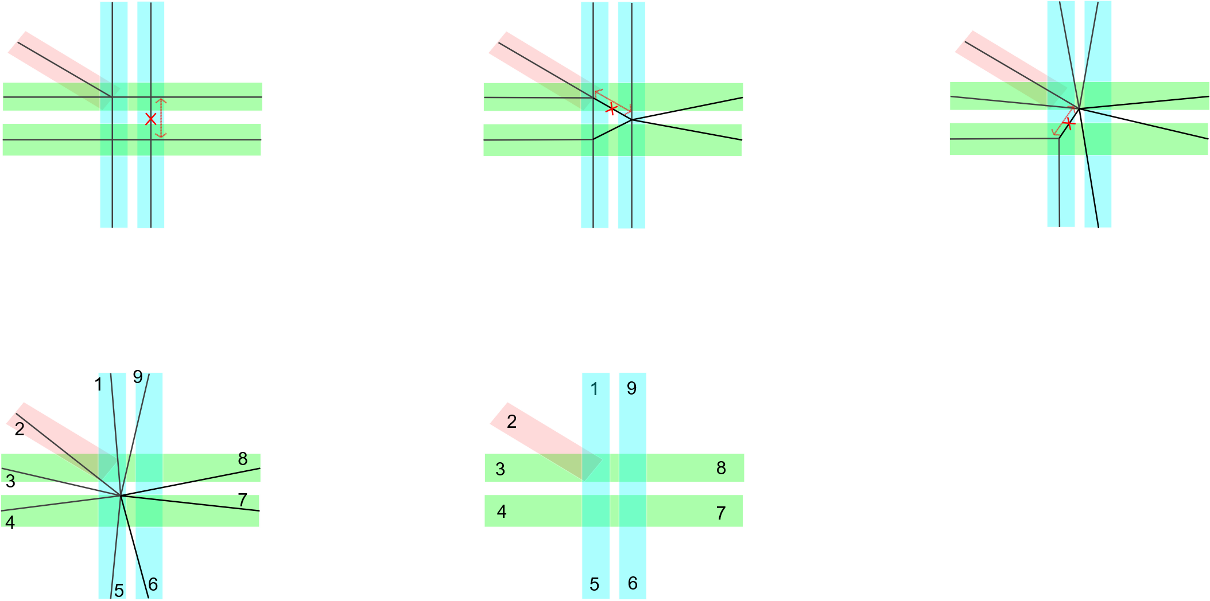

##### d

##### e

##### a

##### b

##### c

##### Figure 6: for multi-node intersections we find a virtual mid-point and collapse the incident segment, then order using the counterclockwise order

At signalized intersections we process both directions of a divided highway as one crossing stage because bikes will cross when the light is green and, like cars, they can cross the road in one stage. For example, a through-crossing of a divided highway is considered a one-stage crossing. However, a left-turn at a 6 leg intersection where a street represented by a centerline is crossing a divided highway, we consider a two stage crossing processing the crossing over two directions as one stage, and another when crossing over the single-line street.

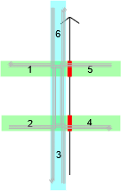

##### Figure 7: multi-node intersections’ one-stage crossing movement model

When crossing over divided highways, the crossing attributes of the segments being crossed are aggregated for each stage. For example, the crossing length of the first stage in a left turn at a two stage multi-node intersection is the sum of the length of crossing of the two directions (for an example without a median).

We find the crossed over segments applying the same modular arithmetic described for the single-node intersections, using the segment indices in the ordered list of incident segments using the ‘virtual node’ procedure explained in this chapter.

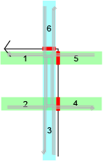

##### Figure 8: multi-node intersections’ two-stage crossing movement model

### 3.5. Crossing movements model and its attributes

For modelling the crossings of the traffic at intersections, we imported the street network line data into the data structure defined previously (segments with references to atomic nodes). We then imported all the additional point type data layers, i.e. the traffic signals, traffic signs, and intersection treatments layers, and update the existing node features with their attributes using spatial inner join operation. We then iterate through all the segments and update the nodes with a list of incident segments, that is, a list of ids of the segments that each node is referenced by, added to each node’s attribute table.

We model the intersection movements from the data in a two stage-process. In the first stage nodes with more than two incident segments are identified and are henceforth called m-nodes (nodes with multiple incident segments). In the second stage, m-nodes involving a dual-carriageway intersection are associated with each other. We then process each intersection, and make an ordered list of incident segments for each intersection, counterclockwise starting due north, storing their indices in a list.

At each intersection we then process all possible crossing movements for going from segment i to segment j where i and j are indices of incident segments in the intersection's ordered list of incident segments. Using the indices of the segments in the intersection's ordered list of incident segments, we can categorize the type of the crossing (through crossing, or left-turn), and find the segment or segments being crossed-over using the from and to segment indices’ modular difference. For example, going from segment 1 to segment 4 in a 4 leg single-node intersection would be categorized as a left turn two stage crossing, and crossing over segments 2 and 3 in terms of their indices in the ordered list of incident segments. Right-turn movements are assigned LTS 1, for anything other than cycle tracks. Cycle tracks left side of bidirectional roads should be processed separately.

For every segment being crossed as part of a crossing movement, we fetch the attributes needed and calculate the crossing LTS for crossing that segment. The attributes include number of lanes being crossed over, speed of the segment being crossed over, the Average Daily Traffic (ADT), and the crossing distance (calculated using the lane widths and number of lanes attributes available in our dataset).

### 3.6. Attributes of a simple crossing (crossing one segment)

For a crossing movement that only crosses one segment, the calculated attributes are presented below.

|  |  |
| --- | --- |
| Attribute name | Notes |
| from_segment_id |  |
| via_node_id |  |
| to_segment_id |  |
| crossing_type | right turn (crosses no segments), through crossing (crosses one segment), left turn (crosses two or more segments). |
| crossing_distance | crossed over segment’s lane widths + bike lanes, parking, shoulder lanes, median, etc. |
| has_traffic_signal | If the intersection node has the traffic signal values other than null, assigned through the import process via a spatial inner join operation with the traffic signal locations’ buffered polygon. |
| has_stop_sign | If the intersection node has the stop sign values other than null, assigned through the import process via a spatial inner join operation with the stop sign locations’ buffered polygon. |
| stop_sign_road_id | If the intersection node has the stop sign road id values other than null, assigned through the import process via a spatial inner join operation with the stop sign locations’ buffered polygon. For a crossing movement, the stop sign’s road id is checked against the from, and the crossed over segment, for assigning a priority to the crossing movement. |
| is_priorotized | Is the bike expected to stop? Source: based on the presence of ‘stop signs’, and functional classification of the from and the segment being crossed over. |
| crossing_max_speed | Max speed allowed on the segments being crossed over. |
| crossing_nom_lanes | Number of lanes on the segment(s) being crossed over. |
| median_width | The median widths values were added to the street network layer using spatial join before importing into the data structure, thus available in the (crossed over) segment attributes. |
| is_on_dual_carriageway | One of the incident segments of the intersection nodes is a dual-carriageway |
| dual_pair_node_id | Node id of a second node which has the same dual carriageway (name) located either at the end of the to segment, or in beginning of the from segment. A greedy search function is used to search in both directions until it finds and returns the id. |
| compounded_crossing_distance | Using the dual pair node id, the crossing distances of the two sides of the dual carriageway segments + median width. |
| crossing_lts | Based on the crossing LTS criteria tables developed by (*) |

##### 

##### Table D: intersection crossings relation data attributes

## 

## Visualizing the crossing barriers across the street network

### 4.1. Introduction

One of the challenges for implementing a crossing LTS is to come up with a geometry that could be used to visualize the crossing movement in the same plain as the street segments. To visualize a segment’s LTS on a map, it’s common to use color coding (). Another method for segment LTS visualization is by removing higher LTS links from the network, thus emphasizing the low LTS network connectivity. A turning restriction (or a crossing LTS barrier) at intersections is challenging to visualize. There are multiple reasons, one is that a crossing doesn’t have any physical property i.e., Length. Another reason is that some intersections have multiple overlapping barriers (through movement, and multiple left turns), which need to be represented in the correct orientation.

In the following chapter, some of these challenges are addressed. First, representative geometry is created for crossings. For dealing with overlapping crossing movements, we exclude the crossing movements that aren’t critical. A critical crossing is a crossing where its LTS is higher that the LTS of both from and to segment.

### 4.2. A geometry for the crossing relations

For each crossing relation, we create a representative geometry, using the references to the from and the two segments stored in the relation’s data. We cut the from and to segments to 25 meters lengths, store it in a linestring of three points: first is the one-before-last vertex of the from segment, or the first vertex of it if it’s cut at 25 meters whichever comes first; the second point is the via node; and the thirst point is the second vertex of the to segment, or the last vertex if it is cut to 25 meters whichever comes first.

Furthermore, we display only if a crossing stress is critical (crossing stress is critical only if it’s higher than the from and to segment’ LTS). This is because including both would make it very difficult to make any understandable visualization. Because the crossing display is short, 50 meters or less, we use thicker line widths for LTS of the crossing movements to improve their visibility, compared to thinner line widths for the LTS of the segments themselves.

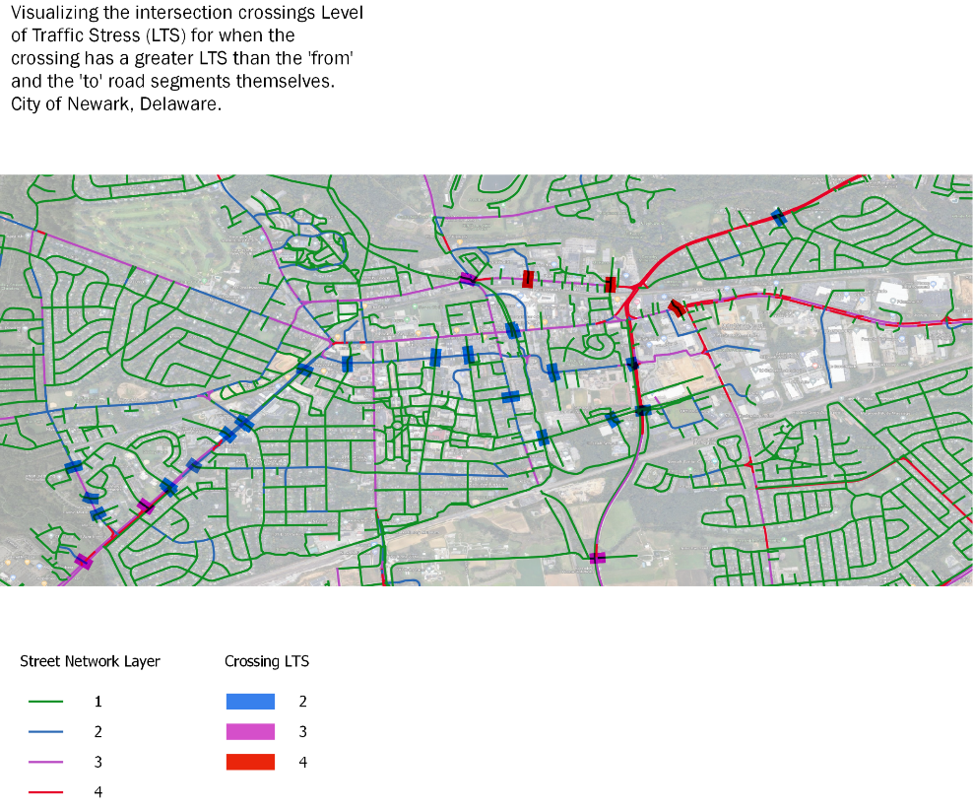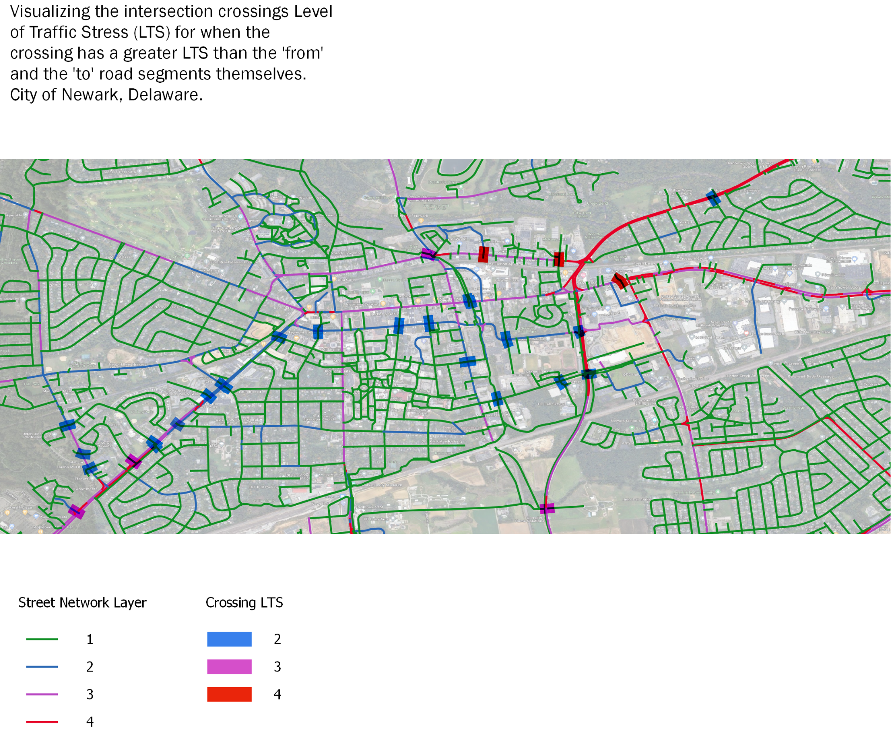

##### Figure 9: Visualizing the intersection crossings Level of Traffic Stress (LTS) for when the crossing has a greater LTS than the 'from' and the 'to' road segments themselves. City of Newark, Delaware.

## Cases from Delaware

A set of examples visualizing the use of the crossing LTS as a measure for analysis of cycling infrastructure are presented in this chapter. These examples are categorized with an emphasis on showing how this measure improves and complements the street segment level of traffic stress. Examples are categorized by the criteria table used in the LTS calculation, into three categories of 1) standalone trails and side paths crossings over two lanes or more, 2) unsignalized intersections crossings, and 3) signalized intersections crossings. For each category, examples are provided to demonstrate various situations found in the Delaware regarding the values from the crossing LTS criteria table of each category.

### 5.1. Standalone trails and side paths crossings

There are many cycling trails and paths across the state of Delaware. Separated from vehicle traffic, these trails have low cycling LTS, and the trails crossings over traffic is treated with traffic signals, RRFBs, and crossing islands. Although these intervention work in majority of trails intersection crossings, however, assigning a crossing LTS reviles some to be still barriers to low stress cycling, due to a high volume of traffic, high speed limit, or long crossing distances.

#### 5.1.1. Heritage Greenway trail crossing Delaware street, city of New Castle, Delaware

In terms of the data structures defined before, crossing over the Delaware street on the Heritage Greenway trail is analyzed based on table A because the intersection’s node has RRFB and crossing islands attribute values other than null, meaning it has found nodes from the RRFB layer, and the crossing islands layer in proximity. Moreover, the crossing involves passing over 2 lanes, and the max speed of the segment being crossed over of 35 mph. Average daily traffic of the segment being crossed over being 19,925 results in the crossing LTS to be looked up as 2. The example demonstrates the intersection model’s utility to find barriers that disturbs the designed low stress cycling infrastructure which is impossible if only looking at the segments themselves.

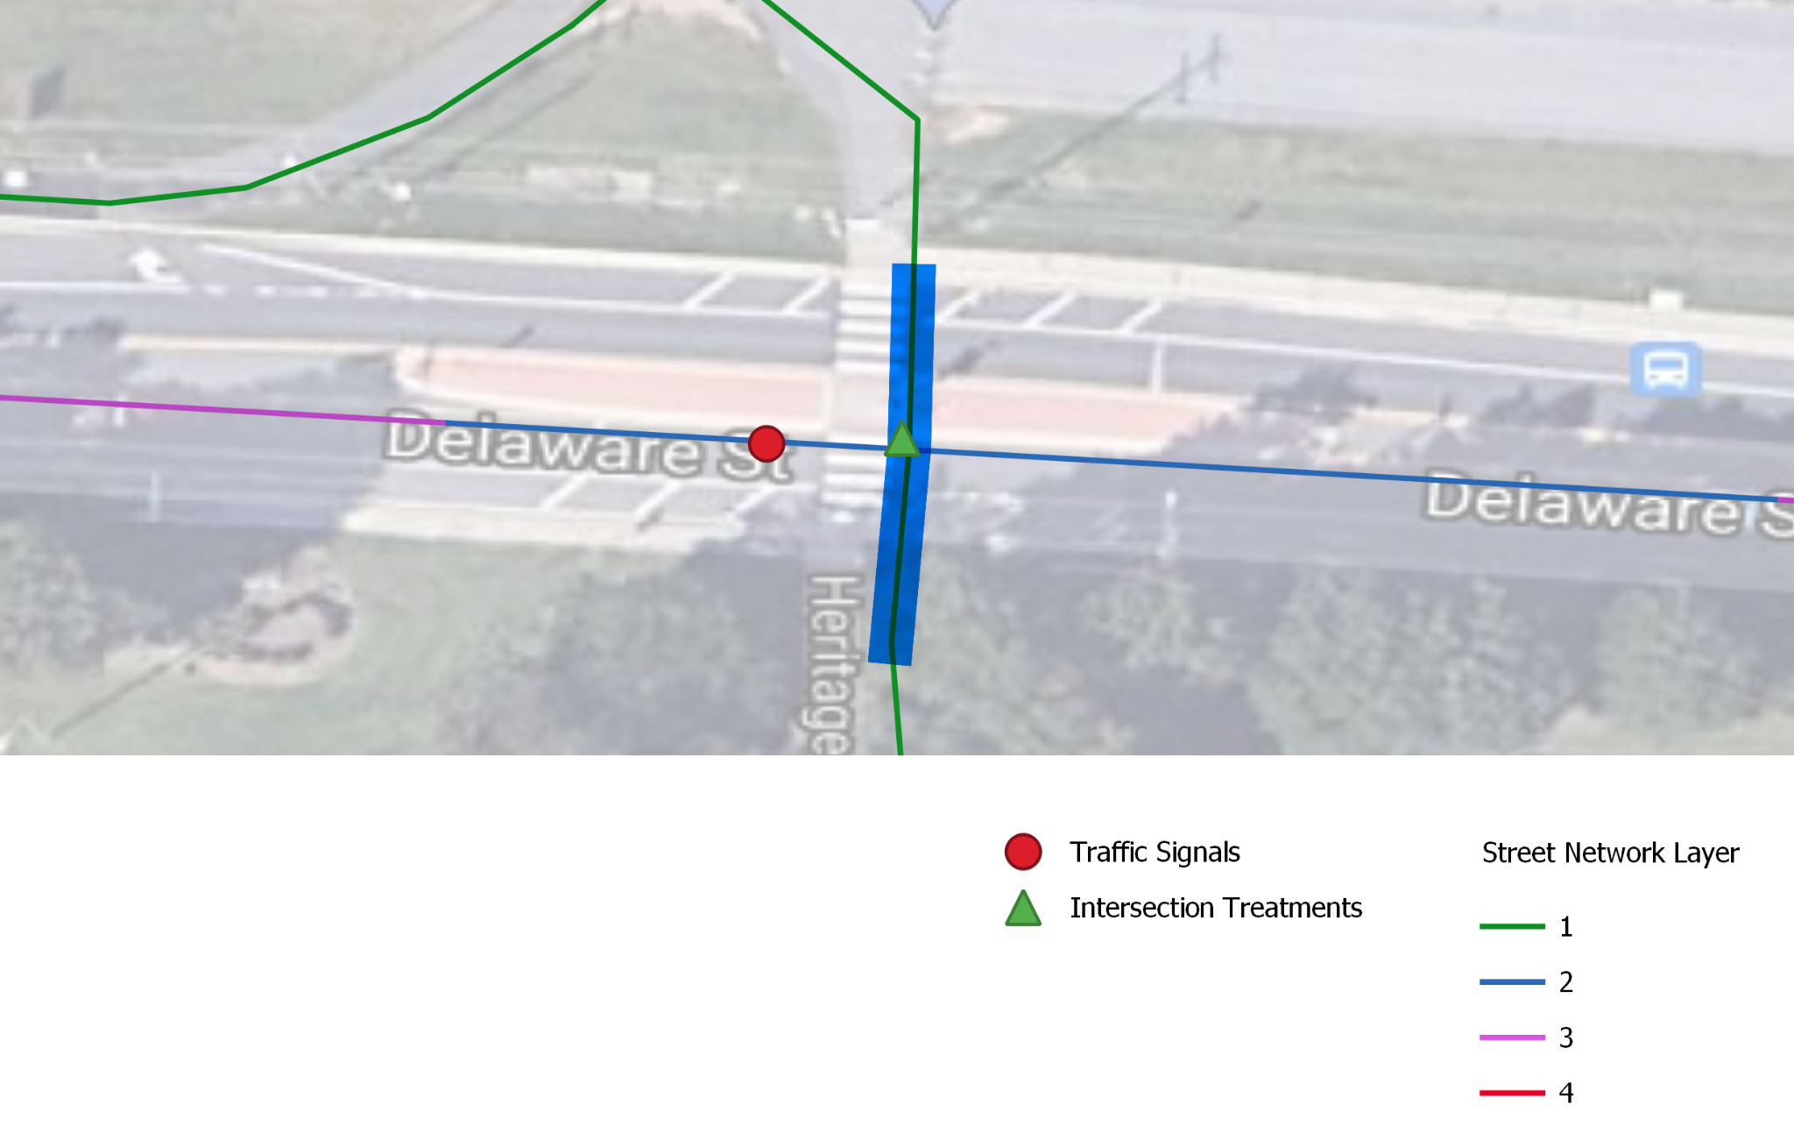

##### Figure 10: Crossing LTS of 2 acting as a barrier to low stress cycling infrastructure in Heritage Greenway trail crossing Delaware street, city of New Castle, Delaware

#### 5.1.2. Jack A. Markell (JAM) Trail crossing over Boulden Boulevard

RRFB and crossing islands values are available in the Jack A. Markell trail and Boulden boulevard intersection’s node attribute. The crossing involves passing over two through lanes, and the max speed and the average daily traffic of the segment being crossed over are 40mph and 13,547 respectively, thus the crossing LTS of 2 is looked up from Table A.

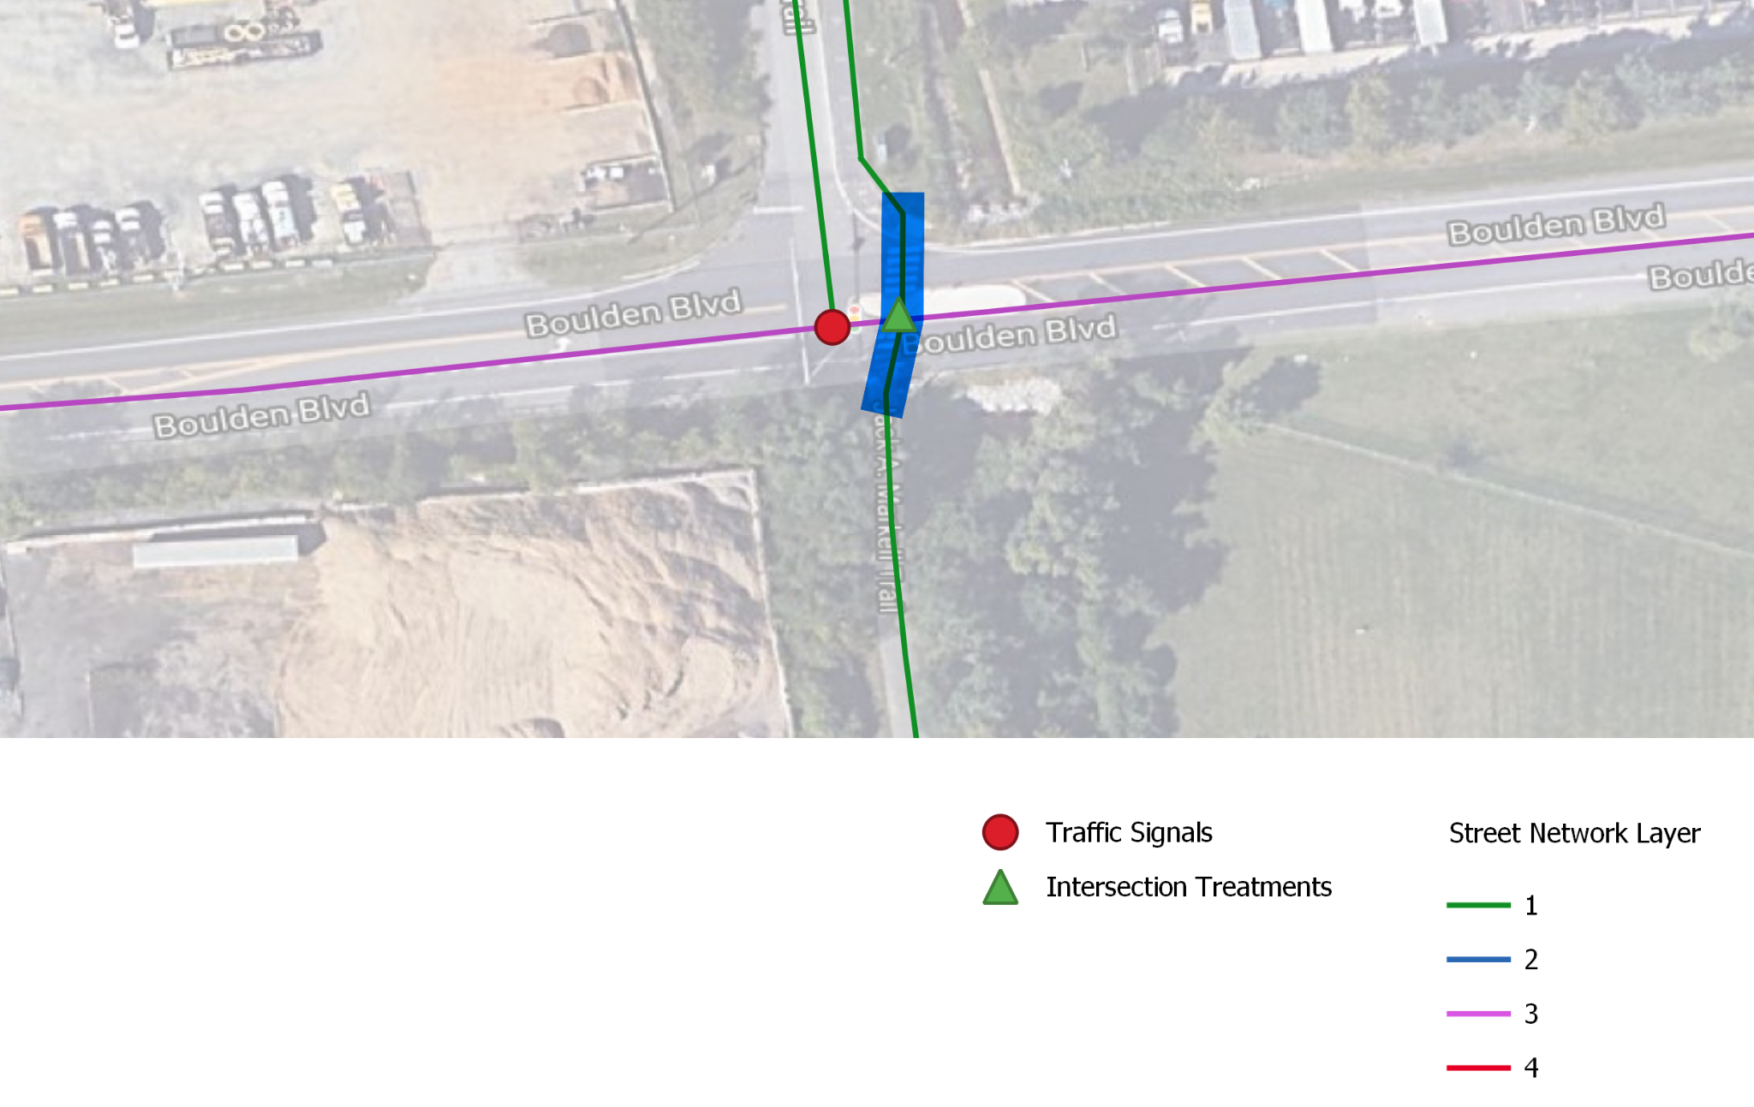

##### Figure 11: Crossing LTS of 2 acting as a barrier to low stress cycling infrastructure in Heritage Greenway trail crossing Delaware street, city of New Castle, Delaware

### 5.2. Unsignalized crossings crossed traffic speed of less than 35 mph

#### 5.2.1. Lancaster Avenue, Wilmington

Unsignalized crossings over Lancaster Avenue, Wilmington involves crossing 4 through lanes, with average daily traffic of 26,792 and maximum speed of 25mph creates a crossing LTS of 4. Even though there are signalized intersections crossing of LTS 1 over Lancaster Avenue, they would introduce a significant detour considering that Lancenster avenue itself is a LTS 4 facility, and as a result disrupting the low stress cycling infrastructure. In fact, results in Delaware include many higher stress crossings over lower stress segments, which are near a lower stress crossing alternative, that are result of human interventions such as being signalized but are connected via high stress segments. This shows how the combination of segment LTS and crossing LTS could change the analysis significantly in comparison to if only using one of these measures.

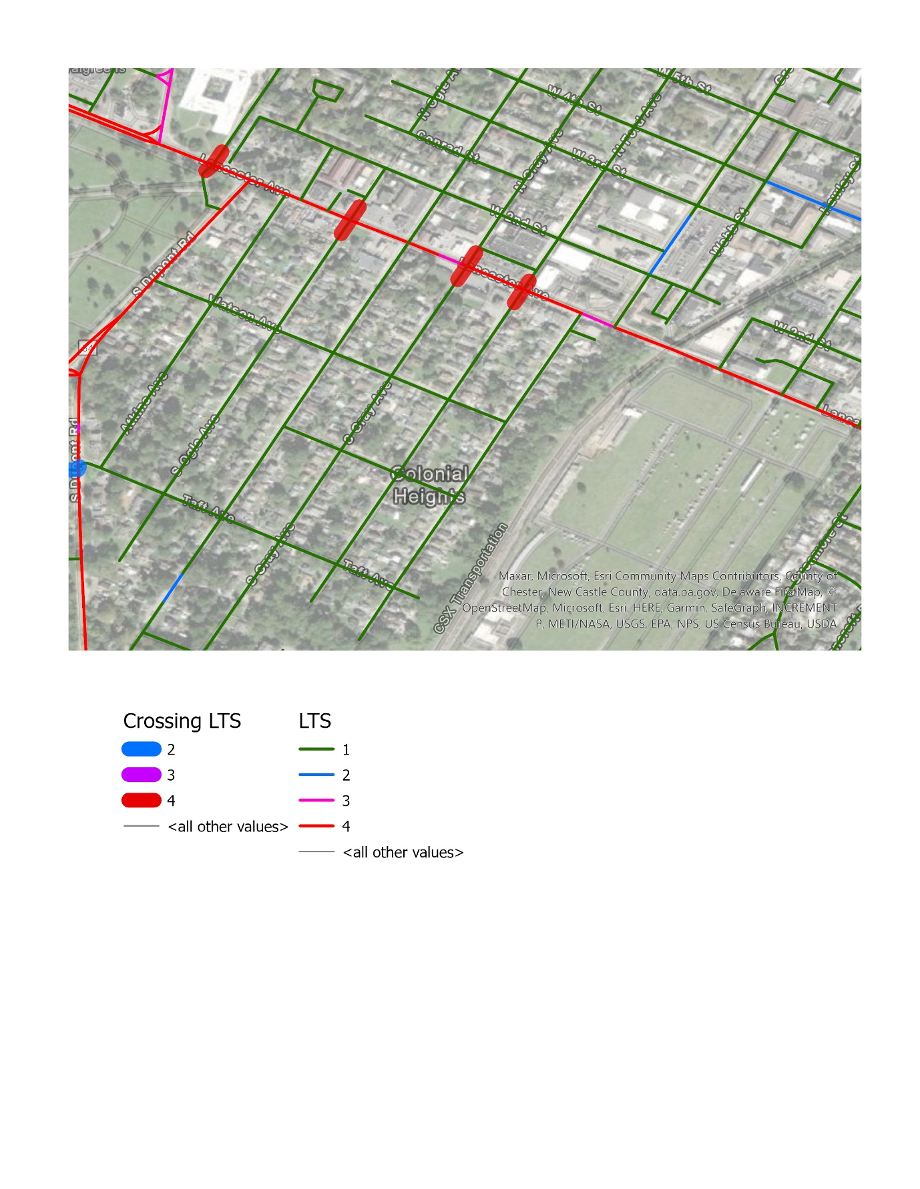

##### Figure 12: Crossing LTS of 4 in unsignalized intersections over Lancaster Avenue in Wilmington, Delaware

#### 5.2.2. South Broad street, Middletown, Delaware

#### 

##### Figure 13: Crossing LTS of 3 in unsignalized intersections over S Broad street in Midletown, Delaware

### 5.3. Unsignalized crossings crossed traffic speed of more than 35 mph

#### 5.3.1. Bristol Lane/Karrington Drive crossing the Corner Ketch road

Even though the low stress local streets are connecting two sides of the neighborhood, however, if looking at the crossing LTS, in fact, the two sides of the Corner Ketch road are disconnected because of unsignalized crossing over 18,609 ADT and 40 mph speed limit of the corner Ketch road.

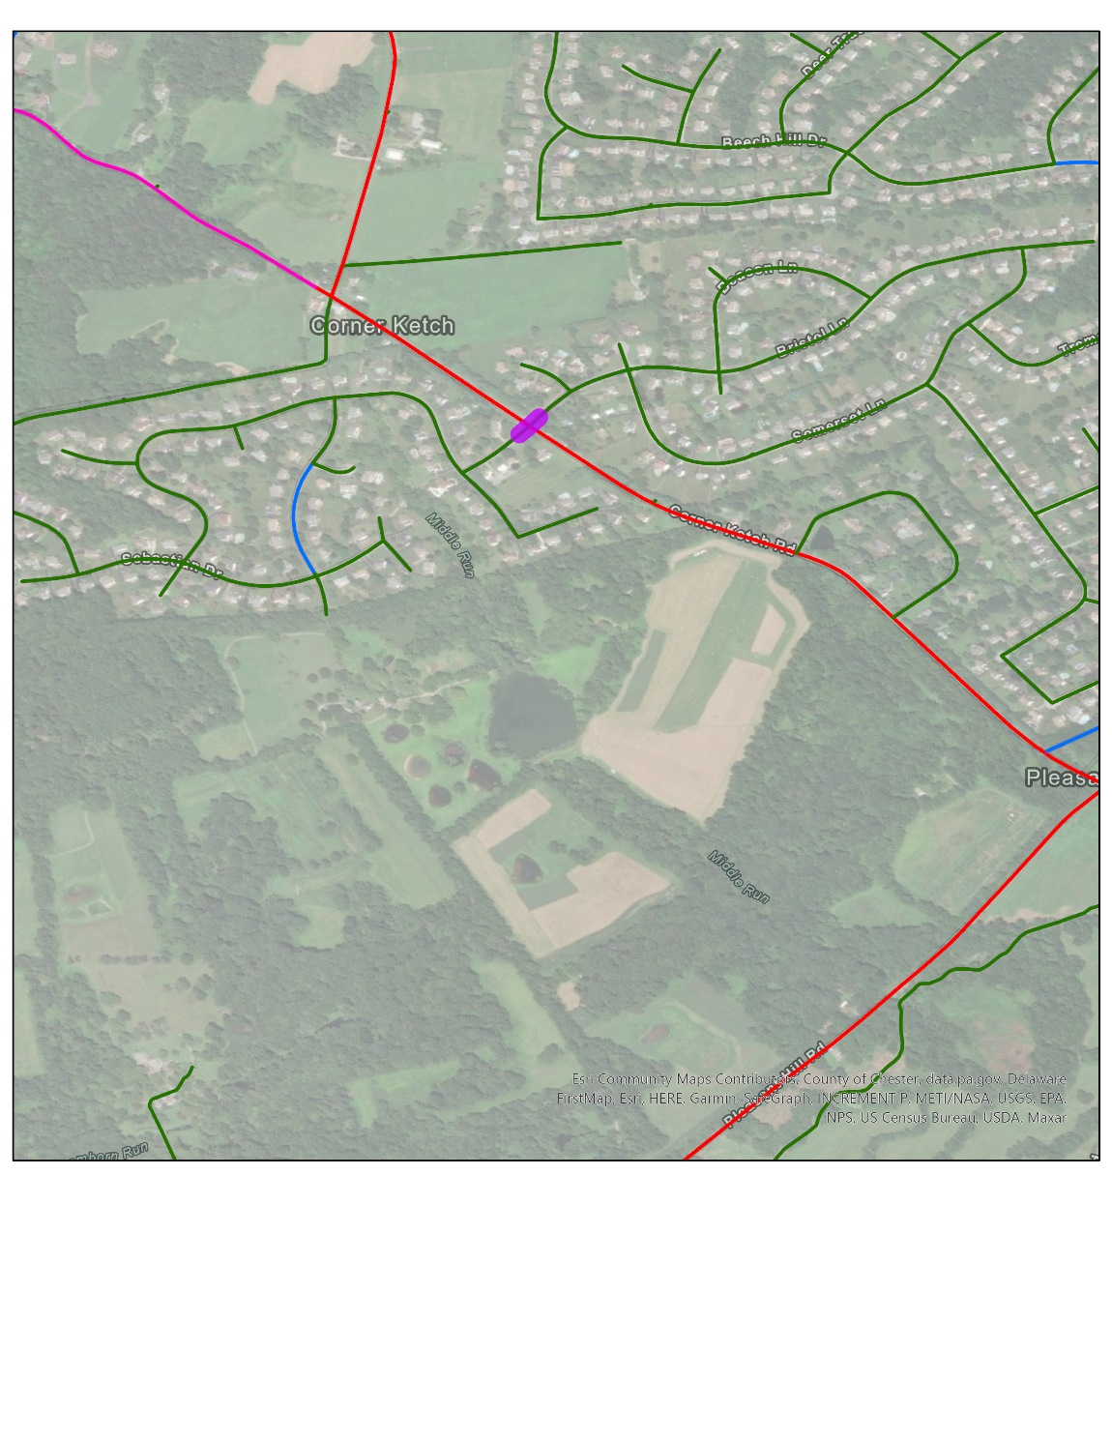

##### Figure 14: Crossing Corner Ketch road, Corner Ketch, Delaware

### 5.4. Signalized crossings Crossing distance more that 100 ft

Due to difficulties in collecting data on signal timings in a statewide scale, the only criteria applied for the signalized crossings is if the crossing distance is more than 100 ft, which will demote a crossing LTS of 1 to a crossing LTS of 2.

#### 5.4.1. Isaac Branch Greenway crossing Willow Grove road in Dover

Isaac Branch Greenway’s otherwise long stretch of LTS 1 cycling network is cut off by such a situation at its intersection with Willow Grove road in Dover .

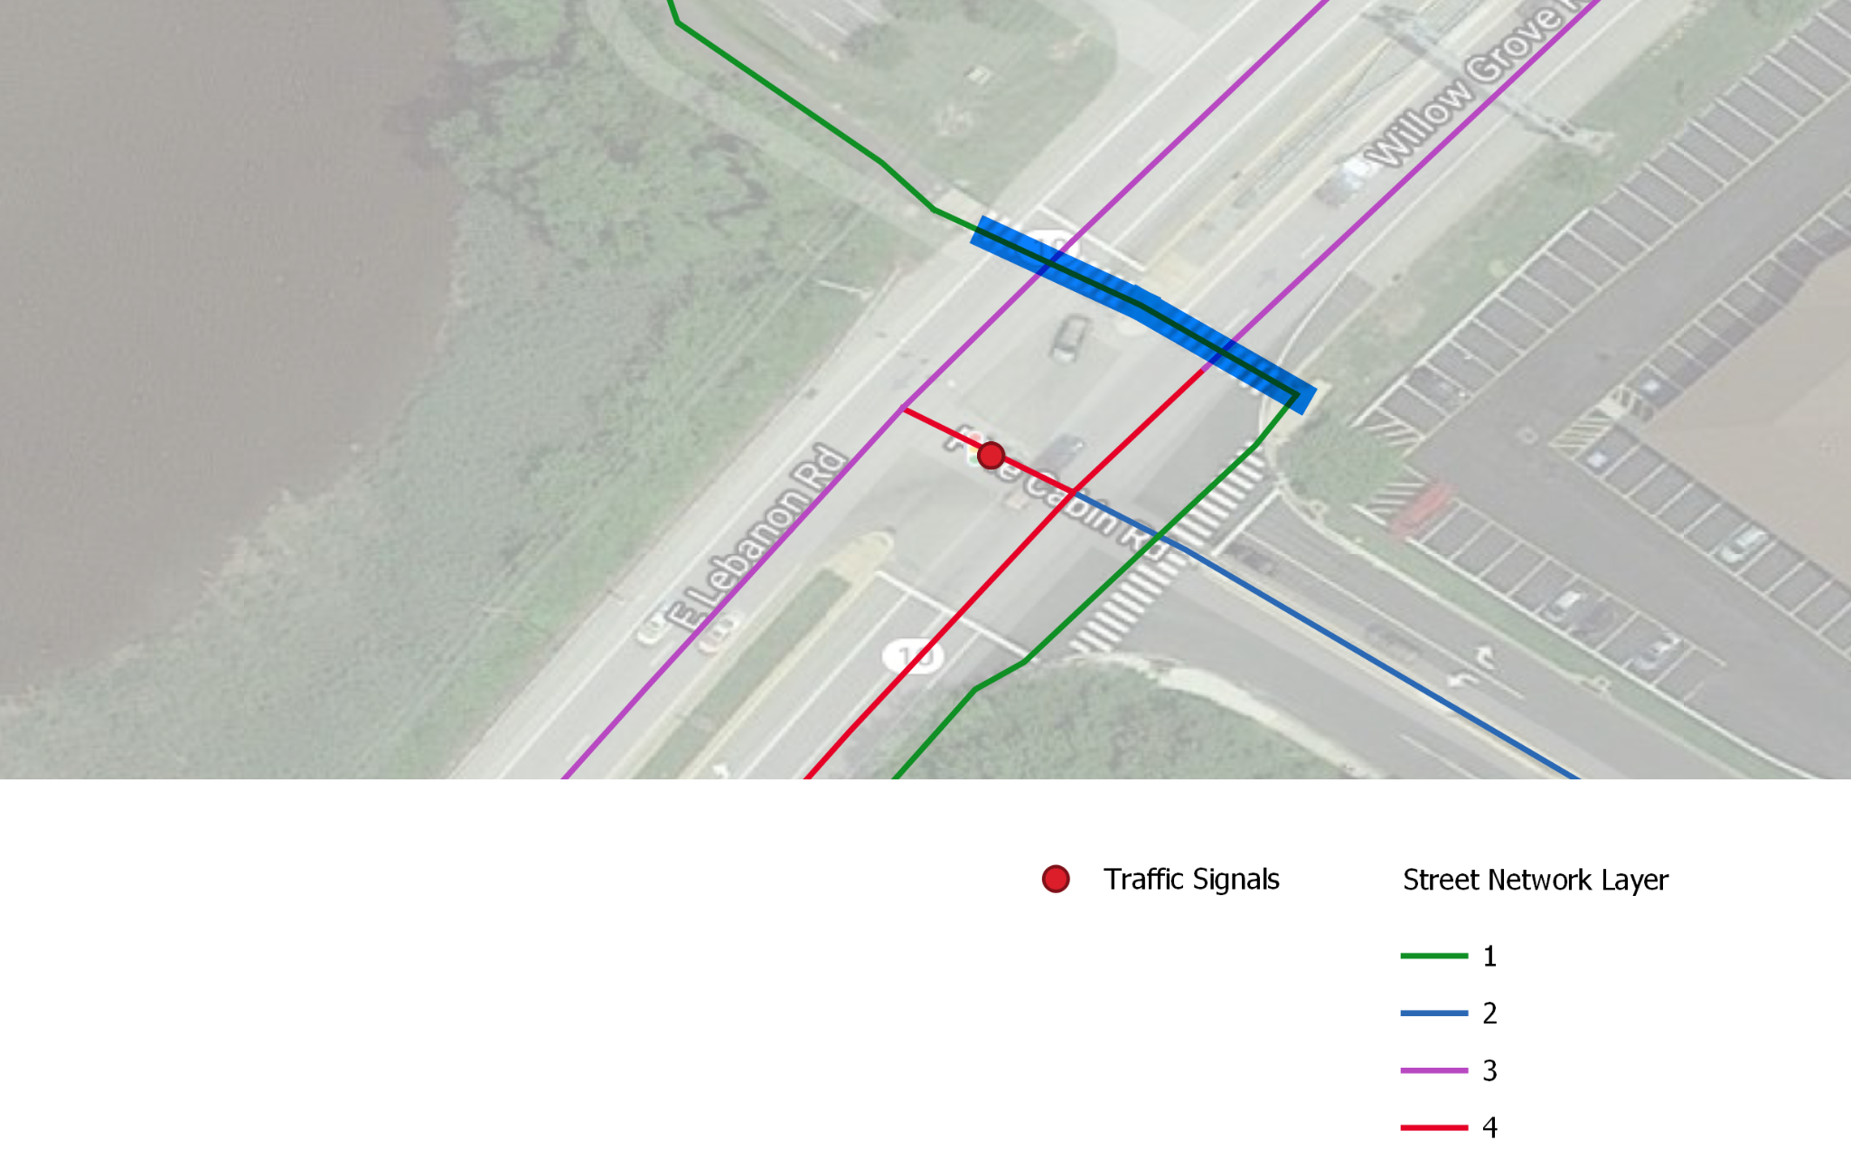 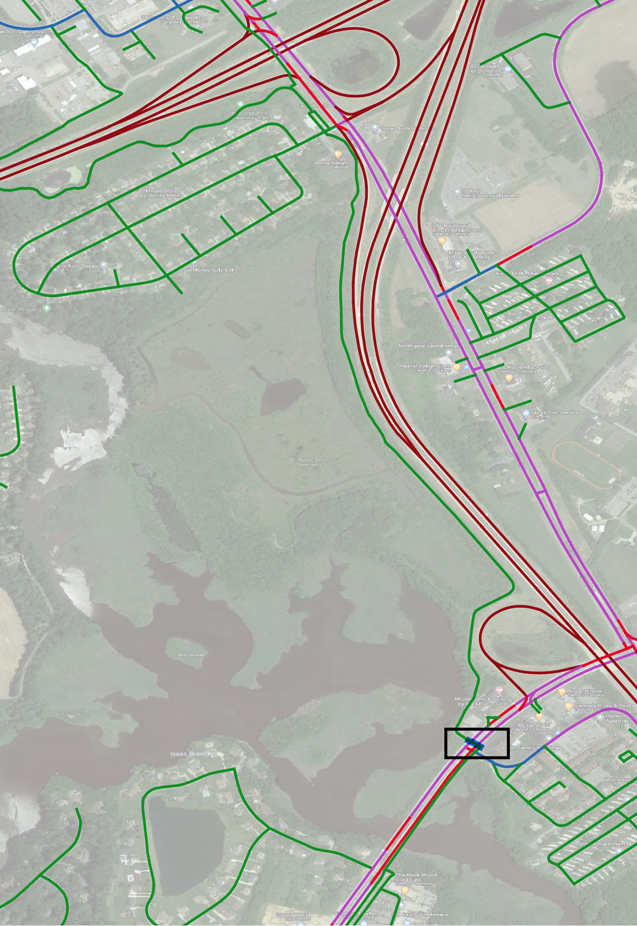

##### Figure 15: Otherwise long stretch of LTS 1 cycling network of Isaac Branch Greenway is cut by Willow Grove road in Dover

#### 5.4.2. Crossing Chesnutt Hill road, and South College Avenue, Newark Delaware

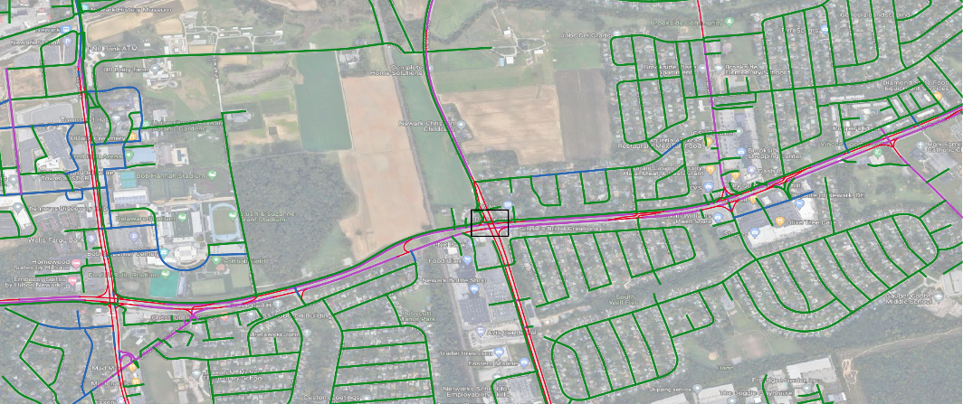

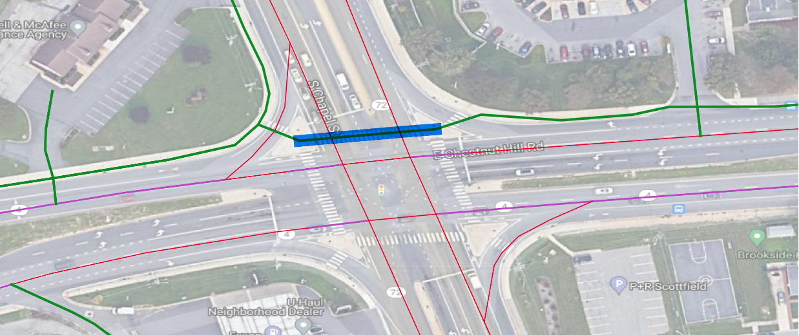

##### Figure 16: Crossing the Chesnutt Hill road and South College avenue intersection on the

## Current issues and future works

There are two implications of this work when thinking about improving the cyclability in transportation network. First is to think about the crossibility of a street, which could be assigned to each street in two points, a starting point and an end point crossibility. Second,

### 6.1. Unsignalized crossing of dual-carriageways as two-stage crossing movement

Crossing a dual-carriageway is a two-stage crossing movement if there is a long enough distance between each direction of the dual-carriageway (more than 25 ft).

##### 

##### figure 16: Crossing the Dupont Boulevard in Selbyville, Delaware.

For example, when Gumboro road crosses the Dupont boulevard in Selbyville, the two directions of the dual-carriageways are separated by a 460 ft median divider segment which enables a two stage crossing movement, with stopping stage after crossing the first centerline and before crossing the second centerline.

### 6.1. Unsignalized crossing of dual-carriageways as one-stage crossing movement

Crossing a dual-carriageway is a one-stage crossing movement if there isn’t a long enough distance between each direction of the dual-carriageway (less than 25 ft).

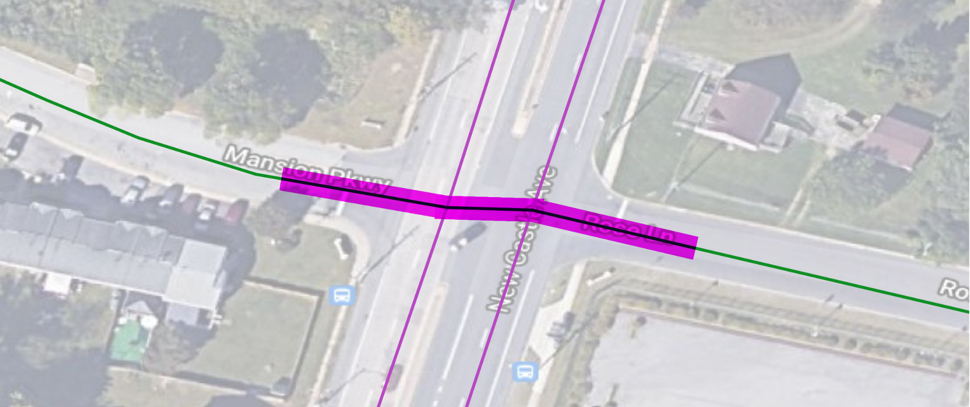

##### Figure 17: Crossing the New Castle avenue in Wilmington, Delaware

## 

## 

## Pseudocode for the procedure

In order to make the analysis replicable, we provide the pseudocode of the algorithm used for structuring and assigning the level of traffic stress to intersection crossings.

GET the **Node**

GET **IncidentSegments** of Node

SET **IncidentSegmentsCC** = IncidentSegments in descending order (i.e. counterclockwise) based on their true bearing (i.e. starting due North)

FOR **incident_segment** OF IncidentSegments

SET incident_segment[**cc**] = IncidentSegmentsCC.**indexOf**(incident_segment)

ENDFOR

FOR **ci** FROM 1 TO **N**(IncidentSegments)

GET segment with cc = ci; SET i TO segID

FOR **cj** FROM 1 TO **N**(IncidentSegments) WHILE ci != cj

GET segment with cc = cj; SET j TO segID

CASE mod(cj – ci, N(IncidentSegments)) OF

- 1: right turn or through T crossing // ; SET lts TO 1

- 2: one-stage crossing: left turn on T crossing, through on a T crossing or a 4 leg intersection

o cc of segment-being-crossed-over = mod(ci + 1, N(IncidentSegments)); SET k TO segID of segment-being-crossed-over;

// o CALL SUBMODULE ltsCalc WITH i, k RETURNING lts

- 3: two-stage crossing: left turn on 5 leg intersections,

// crossing multiple segments

// concise implementation “

o crossing over mod(ci + 1, N(IncidentSegments)) - 1 number of individual segments

o cc of segments-being-crossed-over = mod(ci + 1, N(IncidentSegments)) and mod(ci + 2, N(IncidentSegments));

o FOREACH k OF segments-being-crossed-over;

o CALL SUBMODULE ltsCalc WITH i and k RETURNING lts;

ENDFOREACH

RETURN max(LTS, ck)

- n: number of individual segments being crossed over = n - 1: left turn on crossing dual-carriageway of 6 leg intersections,

WHILE 1 <= i <= n - 1:

o cc of segments-being-crossed-over = mod(ci + i, N(IncidentSegments)); SET k TO segID of segment-being-crossed-over;

// o CALL SUBMODULE ltsCalc WITH i, k RETURNING lts

ENDWHILE

// CALL SUBMODULE ltsCalc WITH i and k RETURNING lts; ENDFOREACH

ENDCASE

STORE LTS for relation of (i, j, nID) = lts (i is from_segID, j is to_segID, and nID is via_nodeID)

ENDWHILE ENDFOR

ENDFOR

SUBMODULE ltsCalc (i, k)

COMPUTE priority i over k WITH i[attributes_from_street] k[attributes_from_street] i[stop_at_end] RETURNING priority i over k

CASE priority i over k of

local-crossing-local: SET lts TO 1

4-way Stop: SET lts TO 1

i has priority over k: SET lts TO 1

k has priority over i: COMPUTE lts WITH k[adt] k[speed] k[has_rrfb] k[has_xingisland] k[lanes] k[crossing_len] RETURNING lts

ENDCASE

RETURN lts

ENDSUBMODULE

[Goodchild, M. F., Yuan, M. & Cova, T. J. (2007). Towards a general theory of geographic representation in GIS. *International Journal of Geographical Information Science*, *21*(3), 239–260. https://doi.org/10.1080/13658810600965271  
Karduni, A., Kermanshah, A. & Derrible, S. (2016). A protocol to convert spatial polyline data to network formats and applications to world urban road networks. *Scientific Data*, *3*(1), 160046. https://doi.org/10.1038/sdata.2016.46](about:blank)